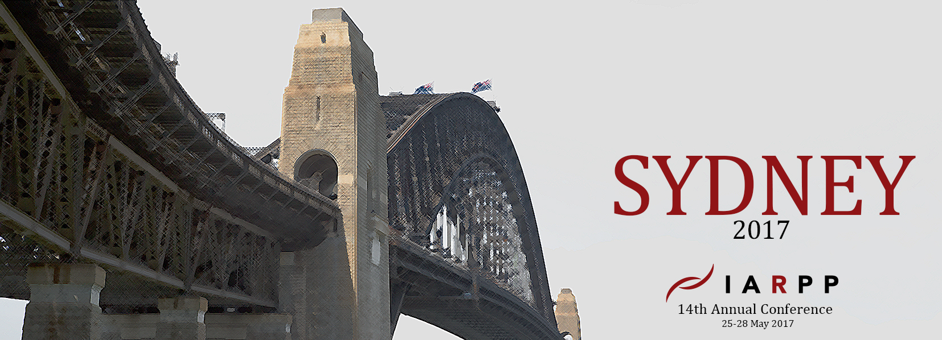

14th ANNUAL IARPP CONFERENCE: SYDNEY, AUSTRALIA
25-28 MAY 2017

FROM THE MARGINS TO THE CENTRE:
CONTEMPORARY RELATIONAL PERSPECTIVES
Co-hosted by the Australian and New Zealand Chapters of IARPP

Progress and creativity thrive when familiar concepts and ideas are seen from new angles. Those who live, work and think at the margins, at the edges, away from the centre, necessarily have perspectives that differ from those who look from the centre, or from the mainstream. In this conference, in acknowledgement of the fact that Australia and New Zealand are geographically very far away from the centre ‒ down-under – we would like to encourage presentations that offer new and creative ways of looking at, thinking about, and practising psychoanalysis and psychotherapy.
WE INVITE YOU TO JOIN US!
The conference venue is the SMC Conference Centre, located in Sydney’s city centre, with easy access to accommodation and transport. The conference website (now live) www.iarppsydney2017.com contains preliminary information and will regularly be updated with accommodation options, flight information, travel suggestions within Australia and New Zealand, visa requirements, dining options and more. The call for papers will go out soon, but in the meantime, please:
SAVE THE DATES: 25 – 28 May 2017
For further enquiries, contact us on iarppsydney2017@gmail.com
Conference Co-Chairs: Cathy Hicks, PhD (Australia); Sarah Calvert, PhD (New Zealand)
International Steering Committee: Alejandro Avila Espada PhD, Sharon Ziv-Beiman PhD, Susi Federici-Nebbiosi PhD, Hazel Ipp PhD, Juan Francisco Jordan Moore PhD, Gianni Nebbiosi PhD, Rina Lazar PhD, Chana Ullman PhD
Local Organizing Committee: Mary Bayles MSW, Lesley Brokenshire, Margie Chodos MFCT, Annette Conradi MFCT, Roberto D’Angelo PsyD MBBS, Margaret Pearl, Daud Saeed MBBS FRANZCP, Claire Virtue MSW, Dale Wiren NZRP.

